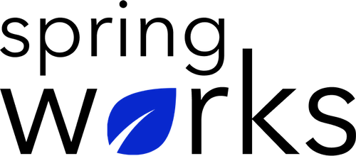
Free Template – Employee Performance Appraisal

Use this survey to see what people managers think about employees' work.

This Employee Performance Appraisal is an evaluation or review about employee’s performance and growth . Copy this template to your Google Drive and customize it for your organization.

Communication (to be added as review instructions):

All answers you give will be treated with the utmost sensitivity, and the information will not be used for any other purpose apart from planning and improvement. Please answer this quick survey by <HOUR OF THE DAY> on <DATE>.

Demographic Information:

The following information is requested so that meaningful analysis and comparisons of group results can be made. Please check the circle, corresponding to your answer.

Q: Your Gender:

- Male
- Female

Q: Your Department:

- Marketing
- Operations
- Tech
- Accounting
- HR

Q: Company Service:

- Under 1 Year
- 1-2 Year
- 3-5 Year
- 6-10 Year
- 10-15 Year
Employee Performance Appraisal Questionnaire

To answer clearly what you think or feel about each item, please follow these steps:

- Read each item fully before you start to mark your answer.
- Pick the one answer which most nearly says what you think or how you feel.
- While completing the questions, be sure to read the special instructions which are included.

Choose the answer which is most appropriate (Strongly Agree = 5 and Strongly Disagree =1)

Q: This employee stands behind the quality of work:

- 5
- 4
- 3
- 2
- 1
- N/A

Q: This employee takes the work assigned seriously:

- 5
- 4
- 3
- 2
- 1
- N/A

Q: This employee is attentive during the working hours:

- 5
- 4
- 3
- 2
- 1
- N/A

Q: This employee delivers good quality work:

- 5
- 4
- 3
- 2
- 1
- N/A

Q: This employee is productive:

- 5
- 4
- 3
- 2
- 1
- N/A

Q: This employee works well within a team:

- 5
- 4
- 3
- 2
- 1
- N/A

Q: This employee is always open to feedbacks:

- 5
- 4
- 3
- 2
- 1
- N/A

Q: Do you feel This employee is qualified to handle the current scope of work?

- 5
- 4
- 3
- 2
- 1
- N/A

(If you agree, please describe how).

Q: This employee is adaptable to the changes in working environment:

- 5
- 4
- 3
- 2
- 1
- N/A

Q: This employee meets his/ her deadlines:

- 5
- 4
- 3
- 2
- 1
- N/A

Q: This employee handle criticism at work:

- 5
- 4
- 3
- 2
- 1
- N/A

Q: This employee is always ready to support colleagues when needed:

- 5
- 4
- 3
- 2
- 1
- N/A

Q: This employee starts and finishes the work on time:

- 5
- 4
- 3
- 2
- 1
- N/A

Q: This employee never shy away to take extra initiative on a project when required:

- 5
- 4
- 3
- 2
- 1
- N/A

Q: The three things where you think this employee can improve:

i.
ii.
iii.

Q: The three best things where this employee is doing particularly well:

i.
ii.
iii.

Q: Give an example of a situation where you took his/ her help and it was a success?

Q: What else would you like to tell us about?

Many thanks for taking the time to fill in this survey.

